**Hello, World!**

Hello, Normal!

Hello, Color!

Hello, Center!

|  |  |  |  |  |
| --- | --- | --- | --- | --- |
| 1 | | | | 5 |
| 6 | 7 | 8 | 9 | 10 |
| 12 | 13 | | 15 |
| 17 | 20 |
| 21 | 22 | 23 | 24 | 25 |

inline

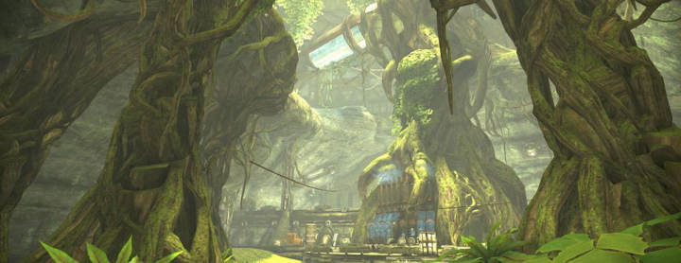

anchor, the top image

